LM Report Asistent – Programmer’s Guide

Skeleton of Analytical Report

Table of contents:

1 Abstract 3
2 Word Loader module 3
3 Skeleton implementation 3
3.1 Attribute id 3
4 Elements of the skeleton 3
4.1 report 3
4.2 chapter 4
4.3 active_element 4
4.4 attributes 4
4.5 element_attributes 4
4.6 attribute 5
4.7 filter 5
4.8 selection 5
4.9 attribute_filter 5
4.10 output 6
4.11 transformation 6
4.12 visualization_values 6
4.13 variable 6
4.14 attr_link_table 6
4.15 link 7
4.16 attr_link 7
4.17 paragraph 7
4.18 text 8
4.19 tab 8
4.20 br 8
4.21 graph 8
4.22 categories 9
4.23 category 9
4.24 chart 10
4.25 value 10
4.26 table 10
4.27 tr 11
4.28 td 11
4.29 include 11

Abstract
In this text we describe the structure of the skeleton of analytical report used in LM-RA. This description may be useful for developers, who want to create a new active element or a new transformation/visualization of an active element. In this text we suppose that, reader is experienced in XML a bit.

Word Loader module
We will sometimes use a reference to WordLoader module in this text. The WordLoader module is a part of the LM-RA system that is responsible for communication LM-RA with the Microsoft Word editor. This module constructs the generated report in Microsoft Word editor. The construction of the report is just a conversion of each element in the skeleton to some text or table or something similar in the output document.
For more information about WordLoader module see chapter “Word Loader module” in “LMRA Integration” par of this Programmers Guide.

Skeleton implementation
The skeleton in LM-RA is just XML DOM of fixed structure. This XML DOM is behind the tree view of Skeleton editor and this XML DOM is saved in .lmra files. The structure of skeleton XML is formally defined in DTD in file “./XML/skeleton_DTD.xml” (relative path from LM-RA install directory. Every skeleton used in LM-RA has to be valid according to this schema.

Attribute id
Many of the elements in LM-RA skeleton have an attribute with the name id. Type of this attribute differs element to element, but mostly it has the type CDATA. In this case the id attribute is used only as user identification tag of the element. It is useful to fill in this attribute. It simplifies the orientation in skeleton and it is useful for WordLoader error handling. When WordLoader raises an error it shows you a message with error description and id text of the last processed element. GUI also uses id attributes.

Elements of the skeleton
In this chapter we will describe all elements that can be placed in skeleton XML DOM. This chapter is divided into sections according to elements. Each section has following structure: heading – name of the element, DTD definition of the element, description of the element and table of attributes of the element.
  - report
<!ELEMENT report ( chapter | include )* >
The top element of every LM-RA skeleton is the report element. It contains some setting attributes and some basic information about the report, which is used by WordLoader in generate process.
attributes:
name | data type | value | description
id | CDATA | #REQUIRED | User identification tag.
title | CDATA | #REQUIRED | Main title of the report.
subtitle | CDATA | #IMPLIED | Subtitle of the report.
author | CDATA | #IMPLIED | Name of the author of the report.
language | CDATA | #IMPLIED | Language of the report “cz” or “en”.
orphans_solution | CDATA | #IMPLIED | ignore, delete, set_default

  - chapter
<!ELEMENT chapter (paragraph | include | active_element | attr_link_table | chapter)* >
The chapter element represents single chapter of a document. It is a basic element into which all other elements are embedded. Chapters can be nested and level of its heading in a document corresponds to its nesting depth.
attributes:
name | data type | Value | description
id | CDATA | #REQUIRED | User identification tag.
title | CDATA | #REQUIRED | Heading of the chapter.
  - active_element
<!ELEMENT active_element ( attributes, filter, filter?, output ) >
This element consists of many parts. Each of the parts has its semantics, which will be described below. More information about active elements can be found in Active elements and visualizations part of LM-RA programmer’s guide.
WordLoader module does not process this element. The kernel of LM-RA has to preprocess these elements before WordLoader generates it to the MS Word.
attributes:
name | data type | Value | description
id | ID | #REQUIRED | User identification tag.
type | CDATA | #REQUIRED | Type identifier.
source | CDATA | #REQUIRED | Data source identifier.
label | CDATA | #REQUIRED | GUI used label.
  - attributes
<!ELEMENT attributes (element_attributes) >
This element contains attributes, which can be referred from attr_link like elements.
  - element_attributes
<!ELEMENT element_attributes (attribute*) >
The attributes loaded from data source and transformed by “Fill element attributes” transformation are stored here.
  - attribute
<!ELEMENT attribute EMPTY >
The attribute element represents one attribute value used in attributes table of attr_link like elements.
attributes:
name | data type | value | Description
name | CDATA | #REQUIRED | Identification name of the attribute.
value | CDATA | #REQUIRED | Actual value of the attribute.
label | CDATA | #IMPLIED | Label displayed by GUI
  - filter
<!ELEMENT filter (selection* | attribute_filter*) >
The active element’s filter data are stored in this filter element. Content of this element differs according to the type filter.
More information about filters can be found in “LMRA Integration” par of this Programmers Guide.
attributes:
name | data type | value | Description
type | (simple | complex) | #REQUIRED | Determines the type of the filter.
  - selection
<!ELEMENT selection EMPTY >
The selection element is used by simple filter. It represents user selection of single object in Simple filter tab of the Active element configuration dialog.
attributes:
name | data type | value | Description
id | CDATA | #REQUIRED | Value of the id attribute of the selected object.
  - attribute_filter
<!ELEMENT attribute_filter EMPTY>
This element represents a single complex filter in Complex filter tab of the Active element configuration dialog.
attributes:
name | data type | value | description
attr_name | CDATA | #REQUIRED | The name of the filtering attribute.
numeric_sort | (true | false) | #REQUIRED | Numeric like sort.
sort_direction | (ascending | descending) | #REQUIRED | Direction of the sort order.
filter_type | (treshold | fixed | top-n) | #REQUIRED | Filtering method.
filter_data | CDATA | #REQUIRED | Parameter of the filtering method. Threshold of fixed value or number of object in the top-n method.
  - output
<!ELEMENT output (transformation* | (chapter | paragraph | graph | table | text | output)*)>
There are two ways of use output element. First way of use is transformation/visualization storage. The second way of use is storage for output of the active element preprocessing. The only part of an active element that can be processed by WordLoader is the content of this output element. For easier manipulation with XML data output elements can be nested.
  - transformation
<!ELEMENT transformation (attr_link_table | visualization_values)? >
This element defines a single visualization that will be used in the generate process. There are three types of visualization. The content of the transformation element differs according to the type of visualization. This content is empty if the type is simple.
attributes:
name | data type | value | Description
type | (attr_link_table | simple | with_options) | #REQUIRED> | Type of the visualization.
name | CDATA | #REQUIRED> | Name of the directory containing desired visualization. Displayed in the visualizations table of an active element.
  - visualization_values
<!ELEMENT visualization_values ((variable)*) >
The visualization_values element contains configuration of a visualization of the with_options type. The configuration is represented as a list of values of option variables, which are stored in variable elements.
  - variable
<!ELEMENT variable EMPTY >
The variable element keeps single option of visualization with options.
attributes:
name | data type | value | description
name | CDATA | #REQUIRED> | Name of the option variable.
value | CDATA | #REQUIRED> | Value of the option variable.
  - attr_link_table
<!ELEMENT attr_link_table (link*) >
The attr_link_table element represents a table of references to attributes of some active element in the skeleton. User can select some of these attributes and type his or her own label to each of them.
The attr_link_table element is used in two ways in the skeleton. First it is a visualization of an active element. Second it is a standalone element in the skeleton. There is no difference in function of attr_link_table in these two ways. The only difference is that the target of the visualization attr_link_table is fixed the to the active element, which encapsulates it.
Attr_link_table elements are transformed (for example to some text or to a table) in the generate process by kernel of LM-RA.
For more information about Attr_link_tables see “LMRA Integration” par of this Programmers Guide.
attributes:
name | data type | value | description
id | CDATA | #REQUIRED | User identification tag.
target | CDATA | #REQUIRED | Id of the target active element.
style | CDATA | #REQUIRED | Name of the transformation used in the generate process.
  - link
<!ELEMENT link EMPTY>
The link element is used in attr_link_table elements ant it represents a reference to a single attribute of the target active element.
attributes:
name | data type | value | description
attr_name | CDATA | #REQUIRED | Name of the target attribute.
caption | CDATA | #REQUIRED | User label of the target attribute.
  - attr_link
<!ELEMENT attr_link EMPTY >
The attr_link element function is similar to the function of the element att_link_table. The attr_link is standalone element of the skeleton. It represents single reference to value of an attribute of some active element. The kernel of LM-RA transforms attr_link element to the element text that contains the value of target attribute.
attributes:
name | data type | value | description
id | CDATA | #REQUIRED | User identification tag.
target | CDATA | #REQUIRED | Id of the target active element.
attr_name | CDATA | #REQUIRED | Name of the target attribute.
style | CDATA | #IMPLIED | MS Word editor style of the text.
  - paragraph
<!ELEMENT paragraph ( graph | table | text | attr_link)* >
The WordLoader module processes this element by inserting a new paragraph to the generated report.
attributes:
name | data type | value | description
id | CDATA | #REQUIRED | User identification tag.
style | CDATA | #IMPLIED | MS Word editor style of the paragraph.
  - text
<!ELEMENT text ( #PCDATA | br | tab )* >
The WordLoader module processes this element by typing the text inside this element to the generated report. The text can contain tab and br elements.
attributes:
name | data type | value | description
id | CDATA | #REQUIRED | User identification tag.
style | CDATA | #IMPLIED | MS Word editor style of the text.
  - tab
<!ELEMENT tab EMPTY >
The WordLoader module inserts a new tab character in pace of this element.
  - br
<!ELEMENT br EMPTY >
The WordLoader module inserts a new break line character in pace of this element.
  - graph
<!ELEMENT graph ( categories? , chart+ ) >
The WordLoader module inserts a new graph in pace if this element. Data of the graph are stored in inner elements.
Type of the graph: The WordLoader module supports any type of graph that your actually installed MS Graph application do. The constants for charttype attribute are taken from enum XlChartType in Microft Graph Object Library. Examples of charttype constants: xlLine, xlPie, xlBarStacked.
The whole list of enum XlChartType constants can be found this way:
Open MS Word Editor ⇒ open Visual Basic editor (Alt + F11) ⇒ Set MS Graph reference (menu Tools/References…) as it is shown in the first image. Then you can see the complete list of XlChartType enum constants in Object Browser (F2) like in the second Image.
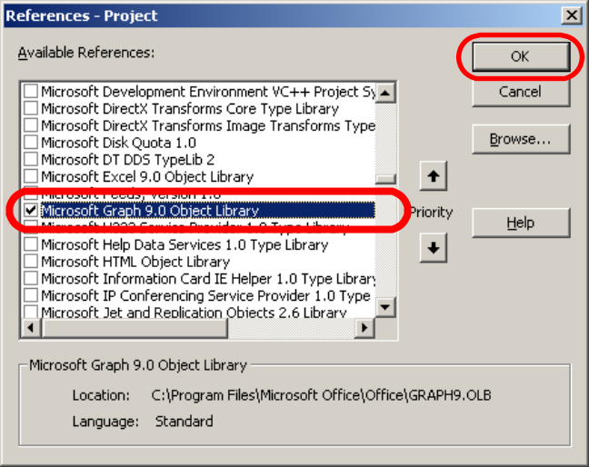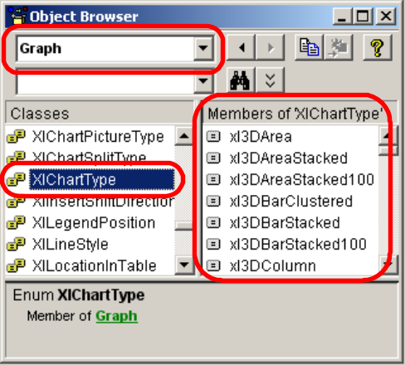
Setting the reference. List of XlChartType constats.
The XlChartType constants can be also found in the Internet.
The value of width and height attributes is floating point number. This number is relative to the page width of the document. Examples: 1 = page with, 5e-1 (0.5 or 0,5 in Czech Windows) = half of the page width. More detailed description of floating point values can be found in chapter 4.25.
attributes:
name | data type | value | description
id | CDATA | #REQUIRED | User identification tag.
title | CDATA | #IMPLIED | Title of the graph.
charttype | CDATA | #REQUIRED | Type of the graph.
showlegend | (true | false) | default: false | Show legend of the graph?
height | CDATA | #IMPLIED | Height of the graph.
width | CDATA | #IMPLIED | Width of the graph.
bgcolor | CDATA | #IMPLIED | #RRGGBB code of the background color.
  - categories
<!ELEMENT categories ( category+ ) >
The categories element encapsulates a list of category element.
attributes:
name | data type | value | description
id | CDATA | #REQUIRED | User identification tag.
  - category
<!ELEMENT category EMPTY >
Categories construct the x-axis of the graph. For example in column chart: each category defines one column. So the number of categories is the number of columns in the chart.
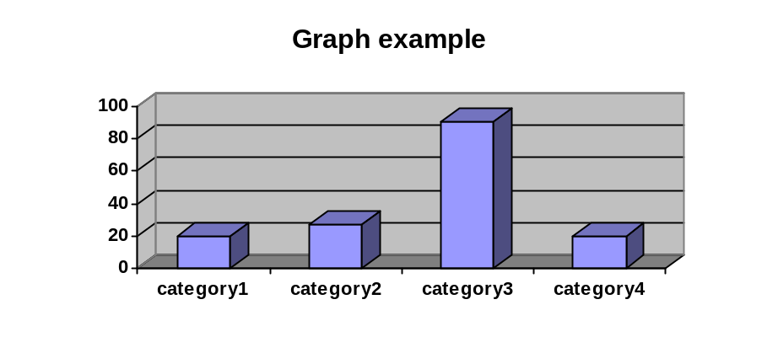
attributes:
name | data type | value | description
id | CDATA | #REQUIRED | User identification tag.
title | CDATA | #REQUIRED | Title of the category shown in the x-axis.

  - chart
<!ELEMENT chart ( value+ ) >
The chart element represents a single row of values in the graph. And it also represents single item in the legend of the graph.
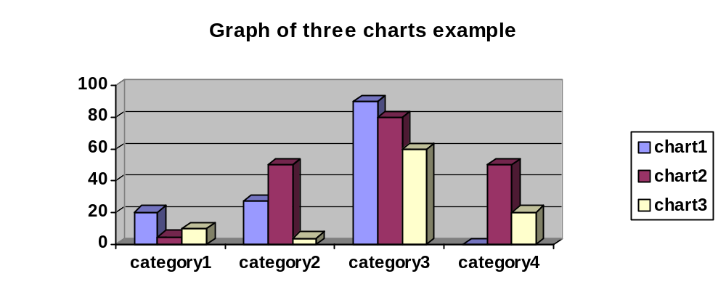
attributes:
name | data type | value | description
id | CDATA | #REQUIRED | User identification tag.
title | CDATA | #IMPLIED | Title of the chart – shown in the legend of the graph.
color | CDATA | #IMPLIED | #RRGGBB code of the color of the chart.
  - value
<!ELEMENT value EMPTY >
The value element represents a single point or column or sector of the graph. It depends on the type of the graph.
The value of the attribute value is (floating point) number. But be careful when using floating point. The format of the number differs according to the setting of Windows. So the number 105e-1 (also usable in this form) is 10.5 no English and 10,5 on Czech Windows.
The value of the attribute value can also ends with “%” (percent) character.
attributes:
name | data type | value | description
id | CDATA | #REQUIRED | User identification tag.
value | CDATA | #REQUIRED | The value.
color | CDATA | #IMPLIED | #RRGGBB code of the color of this part of graph.
  - table
<!ELEMENT table ( tr+ ) >
The table element represents a single table in the document. It has similar structure as the HTML table tag.
The value of the attribute borderwidth is floating point number. This number represents the width of the line in pixels. The significant values for MS Word editor are:
0.25 0.50 0.75 1.00 1.50 2.25 3.00 4.50 and 6.00
More detailed description of floating point values can be found in chapter 4.25.
attributes:
name | data type | value | description
id | CDATA | #REQUIRED | User identification tag.
cols | CDATA | #REQUIRED | Number of columns in the table.
rows | CDATA | #REQUIRED | Number of rows in the table.
borderwidth | CDATA | default: 0 | Width of the border of the table.
  - tr
<!ELEMENT tr ( td+ ) >
The tr element represents a single a single table row. It encapsulates the td elements.
attributes:
name | data type | value | Description
id | CDATA | #REQUIRED | User identification tag.
  - td
<!ELEMENT td ( text? ) >
The td element represents a single cell in a table row. It can contain a text element. The table cell can be merged with some cells after and bellow. This merge behavior is set by colspan and rowspan attributes.
See also chapter 4.26 (the table element). There are some notes about valid border width values.
attributes:
name | data type | value | Description
id | CDATA | #REQUIRED | User identification tag.
colspan | CDATA | #IMPLIED | How many columns merge to this table cell.
rowspan | CDATA | #IMPLIED | How many rows merge to this table cell.
bgcolor | CDATA | #IMPLIED | #RRGGBB code of the background color.
border_top | CDATA | #IMPLIED | Border width of the top border of this table cell.
border_bottom | CDATA | #IMPLIED | Border width of the bottom border of this table cell.
border_left | CDATA | #IMPLIED | Border width of the left border of this table cell.
border_right | CDATA | #IMPLIED | Border width of the right border of this table cell.
  - include
<!ELEMENT include EMPTY >
The include element includes some other document to the report. WordLoader module processes this element.
attributes:
name | data type | value | description
id | CDATA | #REQUIRED | User identification tag.
file | CDATA | #REQUIRED | Path to the included document.

